**Factory Pattern:**

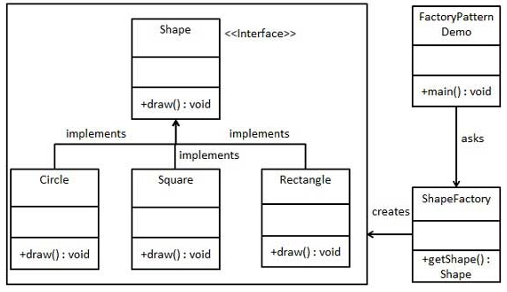

Files: Implementation code.

